**ANDROID LAB**

**CYCLE-1**

**1. Design a Login Form with username and password using LinearLayout and toast valid credentials.**

**activity_main.xml**

<LinearLayout android:layout_height="match_parent"

android:layout_width="match_parent"

android:orientation="vertical"

xmlns:android="http://schemas.android.com/apk/res/android" >

<EditText

android:id="@+id/uname1"

android:layout_width="match_parent"

android:layout_height="wrap_content"

android:hint="Username"

/>

<EditText

android:id="@+id/pass1"

android:layout_width="match_parent"

android:layout_height="wrap_content"

android:hint="Password"

android:inputType="textPassword"

/>

<Button

android:layout_width="match_parent"

android:layout_height="wrap_content"

android:text="Login"

android:onClick="Login"/>

</LinearLayout>

**MainActivity.java**

package com.example.sjcet.login;

import android.support.v7.app.AppCompatActivity;

import android.os.Bundle;

import android.view.View;

import android.widget.EditText;

import android.widget.Toast;

public class MainActivity extends AppCompatActivity {

private EditText unameEditText;

private EditText passEditText;

@Override

protected void onCreate(Bundle savedInstanceState){

super.onCreate(savedInstanceState);

setContentView(R.layout.*activity_main*);

unameEditText = findViewById(R.id.*uname1*);

passEditText = findViewById(R.id.*pass1*);

}

public void Login(View view) {

String username = unameEditText.getText().toString();

String password = passEditText.getText().toString();

if (isValidCredentials(username,password)){

Toast.*makeText*(this,"login Successful",Toast.*LENGTH_SHORT*).show();

}

else{

Toast.*makeText*(this,"invalid credentials",Toast.*LENGTH_SHORT*).show();

}

}

private boolean isValidCredentials(String username,String password){

return username.equals("annjish") && password.equals("12345");

}

}

**OUTPUT**

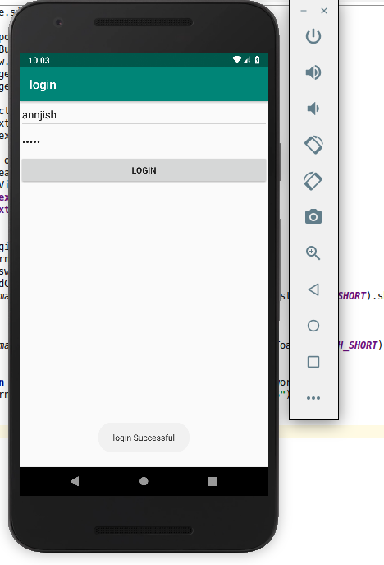

**2.Write a program that demonstrates the Activity Lifecycle.**

**Activity_main.xml**

<?xml version="1.0" encoding="utf-8"?>

<android.support.constraint.ConstraintLayout xmlns:android="http://schemas.android.com/apk/res/android"

xmlns:app="http://schemas.android.com/apk/res-auto"

xmlns:tools="http://schemas.android.com/tools"

android:layout_width="match_parent"

android:layout_height="match_parent"

tools:context=".ActivityLifeCycle">

<TextView

android:layout_width="wrap_content"

android:layout_height="wrap_content"

android:text="Hello World!"

app:layout_constraintBottom_toBottomOf="parent"

app:layout_constraintLeft_toLeftOf="parent"

app:layout_constraintRight_toRightOf="parent"

app:layout_constraintTop_toTopOf="parent" />

</android.support.constraint.ConstraintLayout>

**MainActivity.java**

package com.example.sjcet.activity_life_cycle;

import android.app.Activity;

import android.os.Bundle;

import android.widget.Toast;

public class MainActivity extends Activity {

@Override

protected void onCreate(Bundle savedInstanceState) {

super.onCreate(savedInstanceState);

setContentView(R.layout.activity_main);

Toast.makeText(this, "onCreate Invoked", Toast.LENGTH_SHORT).show();

}

@Override

protected void onStart() {

super.onStart();

Toast.makeText(this, "onStart Invoked", Toast.LENGTH_SHORT).show();

}

@Override

protected void onResume() {

super.onResume();

}

@Override

protected void onPause() {

super.onPause();

Toast.makeText(this, "onPause Invoked", Toast.LENGTH_SHORT).show();

}

@Override

protected void onStop() {

super.onStop();

Toast.makeText(this, "onStop Invoked", Toast.LENGTH_SHORT).show();

}

@Override

protected void onRestart() {

super.onRestart();

Toast.makeText(this, "onRestart Invoked", Toast.LENGTH_SHORT).show();

}

@Override

protected void onDestroy() {

super.onDestroy();

Toast.makeText(this, "onDestroyInvoked", Toast.LENGTH_SHORT).show();

}

}

**OUTPUT**

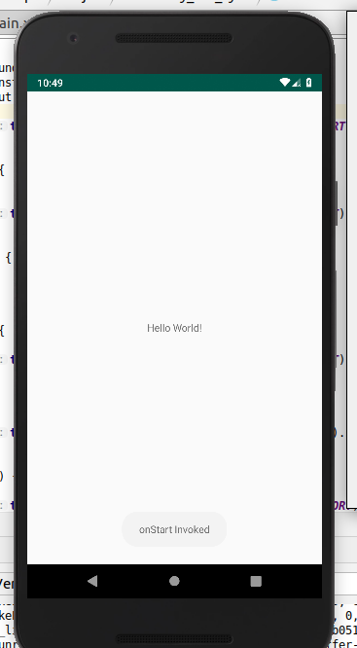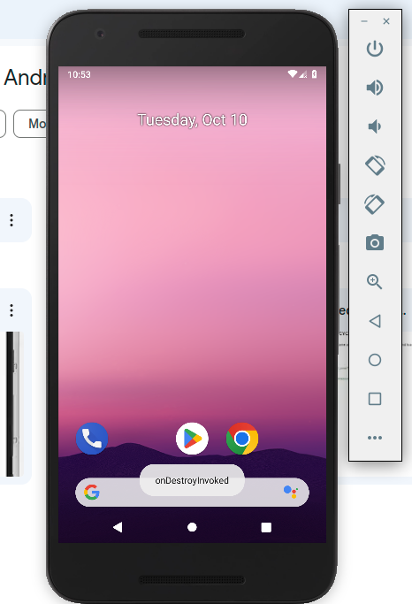

**3.Implementing basic arithmetic operations of a simple calculator.**

**Activity_main.xml**

<LinearLayout

android:layout_width="match_parent"

android:layout_height="match_parent"

xmlns:android="http://schemas.android.com/apk/res/android"

android:orientation="vertical">

<LinearLayout

android:layout_width="wrap_content"

android:layout_height="wrap_content"

android:orientation="horizontal">

<EditText

android:id="@+id/ed1"

android:layout_width="160dp"

android:layout_height="wrap_content"

android:hint="Num 1"/>

<EditText

android:id="@+id/ed2"

android:layout_width="160dp"

android:layout_height="wrap_content"

android:hint="Num 2"/>

</LinearLayout>

<Button

android:layout_height="wrap_content"

android:layout_width="120dp"

android:text="Add"

android:onClick="Add"/>

<Button

android:layout_height="wrap_content"

android:layout_width="120dp"

android:text="Sub"

android:onClick="Sub"/>

<Button

android:layout_height="wrap_content"

android:layout_width="120dp"

android:text="Mul"

android:onClick="Mul"/>

<Button

android:layout_height="wrap_content"

android:layout_width="120dp"

android:text="Div"

android:onClick="Div"/>

<Button

android:id="@+id/clearButton"

android:layout_width="wrap_content"

android:layout_height="wrap_content"

android:layout_gravity="center"

android:text="Clear"

android:onClick="Clear"/>

<LinearLayout

android:layout_width="wrap_content"

android:layout_height="wrap_content"

android:orientation="horizontal"

>

<TextView

android:layout_width="match_parent"

android:layout_height="wrap_content"

android:text="Result:"

android:textSize="20sp"/>

<TextView

android:id="@+id/tv1"

android:layout_width="160dp"

android:layout_height="30dp"

/>

</LinearLayout>

</LinearLayout>

**MainActivity.java**

package com.example.sjcet.calculator2;

import android.os.Bundle;

import android.support.v7.app.AppCompatActivity;

import android.view.View;

import android.widget.EditText;

import android.widget.TextView;

public class MainActivity extends AppCompatActivity {

EditText ed1,ed2;

TextView tv1;

double num1,num2;

@Override

protected void onCreate(Bundle savedInstanceState) {

super.onCreate(savedInstanceState);

setContentView(R.layout.activity_main);

ed1 = findViewById(R.id.ed1);

ed2 = findViewById(R.id.ed2);

tv1= findViewById(R.id.tv1);

}

public void Clear(View view) {

// Clear the EditText fields

ed1.setText("");

ed2.setText("");

// Clear the result TextView

tv1.setText("");

}

public void Add(View view) {

String num1str = ed1.getText().toString();

String num2str = ed2.getText().toString();

if (!num1str.isEmpty() && !num2str.isEmpty()) {

double num1 = Double.parseDouble(num1str);

double num2 = Double.parseDouble(num2str);

double result = num1 + num2;

tv1.setText(String.valueOf(result));

} else {

tv1.setText("Result: Invalid input");

}

}

public void Sub(View view) {

String num1str = ed1.getText().toString();

String num2str = ed2.getText().toString();

if (!num1str.isEmpty() && !num2str.isEmpty()) {

double num1 = Double.parseDouble(num1str);

double num2 = Double.parseDouble(num2str);

double result = num1 - num2;

tv1.setText(String.valueOf(result));

} else {

tv1.setText("Result: Invalid input");

}

}

public void Mul(View view) {

String num1str = ed1.getText().toString();

String num2str = ed2.getText().toString();

if (!num1str.isEmpty() && !num2str.isEmpty()) {

double num1 = Double.parseDouble(num1str);

double num2 = Double.parseDouble(num2str);

double result = num1 * num2;

tv1.setText(String.valueOf(result));

} else {

tv1.setText("Result: Invalid input");

}

}

public void Div(View view) {

String num1str = ed1.getText().toString();

String num2str = ed2.getText().toString();

if (!num1str.isEmpty() && !num2str.isEmpty()) {

double num1 = Double.parseDouble(num1str);

double num2 = Double.parseDouble(num2str);

if (num2 != 0) {

double result = num1 / num2;

tv1.setText(String.valueOf(result));

} else {

tv1.setText("Result: Division by zero");

}

} else {

tv1.setText("Result: Invalid input");

}

}

}

**OUTPUT**

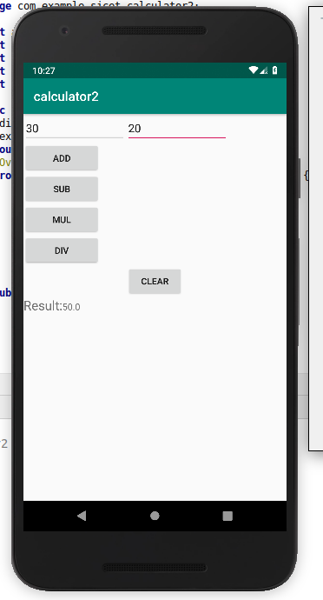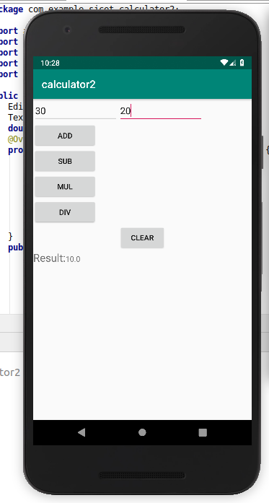

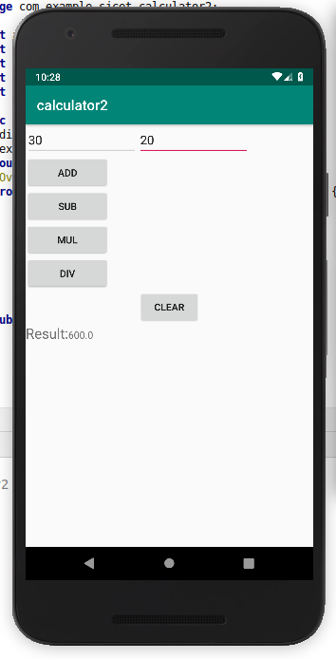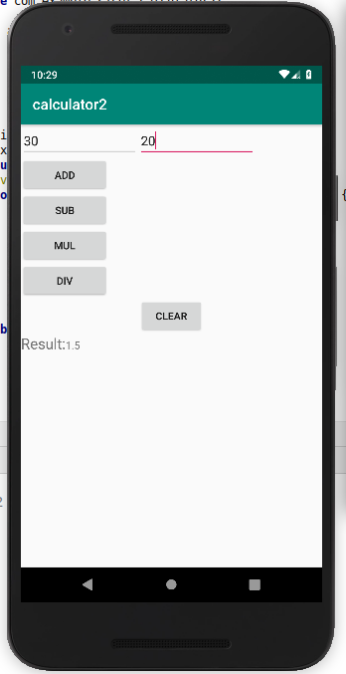

**4.create a student registration form and Implement validations on various UI controls.**

**Activity_main.xml**

<?xml version="1.0" encoding="utf-8"?>

<android.support.constraint.ConstraintLayout xmlns:android="http://schemas.android.com/apk/res/android"

xmlns:app="http://schemas.android.com/apk/res-auto"

xmlns:tools="http://schemas.android.com/tools"

android:layout_width="match_parent"

android:layout_height="match_parent"

tools:context=".MainActivity">

<LinearLayout

xmlns:android="http://schemas.android.com/apk/res/android"

xmlns:app="http://schemas.android.com/apk/res-auto"

xmlns:tools="http://schemas.android.com/tools"

android:layout_width="match_parent"

android:layout_height="match_parent"

android:orientation="vertical"

android:padding="16dp"

tools:context=".MainActivity">

<EditText

android:id="@+id/etName"

android:layout_width="match_parent"

android:layout_height="wrap_content"

android:hint="Name"/>

<EditText

android:id="@+id/etEmail"

android:layout_width="match_parent"

android:layout_height="wrap_content"

android:hint="Email"/>

<EditText

android:id="@+id/etPhone"

android:layout_width="match_parent"

android:layout_height="wrap_content"

android:hint="Phone Number"/>

<RadioGroup

android:id="@+id/rgGender"

android:layout_width="match_parent"

android:layout_height="wrap_content"

android:orientation="horizontal">

<RadioButton

android:id="@+id/rbMale"

android:layout_width="wrap_content"

android:layout_height="wrap_content"

android:text="Male"/>

<RadioButton

android:id="@+id/rbFemale"

android:layout_width="wrap_content"

android:layout_height="wrap_content"

android:text="Female"/>

</RadioGroup>

<TextView

android:id="@+id/tvCoursesLabel"

android:layout_width="wrap_content"

android:layout_height="wrap_content"

android:text="Select Courses:"

android:textSize="16sp"

android:layout_marginTop="16dp"/>

<CheckBox

android:id="@+id/cbMath"

android:layout_width="wrap_content"

android:layout_height="wrap_content"

android:text="Math"/>

<CheckBox

android:id="@+id/cbScience"

android:layout_width="wrap_content"

android:layout_height="wrap_content"

android:text="Science"/>

<CheckBox

android:id="@+id/cbHistory"

android:layout_width="wrap_content"

android:layout_height="wrap_content"

android:text="History"/>

<Button

android:id="@+id/btnSubmit"

android:layout_width="match_parent"

android:layout_height="wrap_content"

android:text="Submit"/>

</LinearLayout>

</android.support.constraint.ConstraintLayout>

**MainActivity.java**

package com.example.sjcet.registrationform;

import android.support.v7.app.AppCompatActivity;

import android.os.Bundle;

import android.view.View;

import android.widget.Button;

import android.widget.CheckBox;

import android.widget.EditText;

import android.widget.RadioButton;

import android.widget.RadioGroup;

import android.widget.Toast;

public class MainActivity extends AppCompatActivity {

private EditText etName, etEmail, etPhone;

private RadioGroup rgGender;

private RadioButton rbMale, rbFemale;

private CheckBox cbMath, cbScience, cbHistory;

private Button btnSubmit;

@Override

protected void onCreate(Bundle savedInstanceState) {

super.onCreate(savedInstanceState);

setContentView(R.layout.activity_main);

etName = findViewById(R.id.etName);

etEmail = findViewById(R.id.etEmail);

etPhone = findViewById(R.id.etPhone);

rgGender = findViewById(R.id.rgGender);

rbMale = findViewById(R.id.rbMale);

rbFemale = findViewById(R.id.rbFemale);

cbMath = findViewById(R.id.cbMath);

cbScience = findViewById(R.id.cbScience);

cbHistory = findViewById(R.id.cbHistory);

btnSubmit = findViewById(R.id.btnSubmit);

btnSubmit.setOnClickListener(new View.OnClickListener() {

@Override

public void onClick(View v) {

// Perform validation

if (validateForm()) {

// Form is valid, process the data

String name = etName.getText().toString();

String email = etEmail.getText().toString();

String phone = etPhone.getText().toString();

String gender = rbMale.isChecked() ? "Male" : "Female";

StringBuilder courses = new StringBuilder();

if (cbMath.isChecked()) courses.append("Math, ");

if (cbScience.isChecked()) courses.append("Science, ");

if (cbHistory.isChecked()) courses.append("History");

// Display a toast with the collected data

String message = "Name: " + name + "\nEmail: " + email + "\nPhone: " + phone

+ "\nGender: " + gender + "\nCourses: " + courses.toString();

Toast.makeText(MainActivity.this, message, Toast.LENGTH_LONG).show();

}

}

});

}

private boolean validateForm() {

// Basic validation for name, email, and phone

boolean isValid = true;

String name = etName.getText().toString();

String email = etEmail.getText().toString();

String phone = etPhone.getText().toString();

if (name.isEmpty()) {

etName.setError("Name is required");

isValid = false;

}

if (email.isEmpty() || !android.util.Patterns.EMAIL_ADDRESS.matcher(email).matches()) {

etEmail.setError("Valid email address is required");

isValid = false;

}

if (phone.isEmpty() || phone.length() != 10) {

etPhone.setError("Valid 10-digit phone number is required");

isValid = false;

}

return isValid;

}

}

**OUTPUT**

